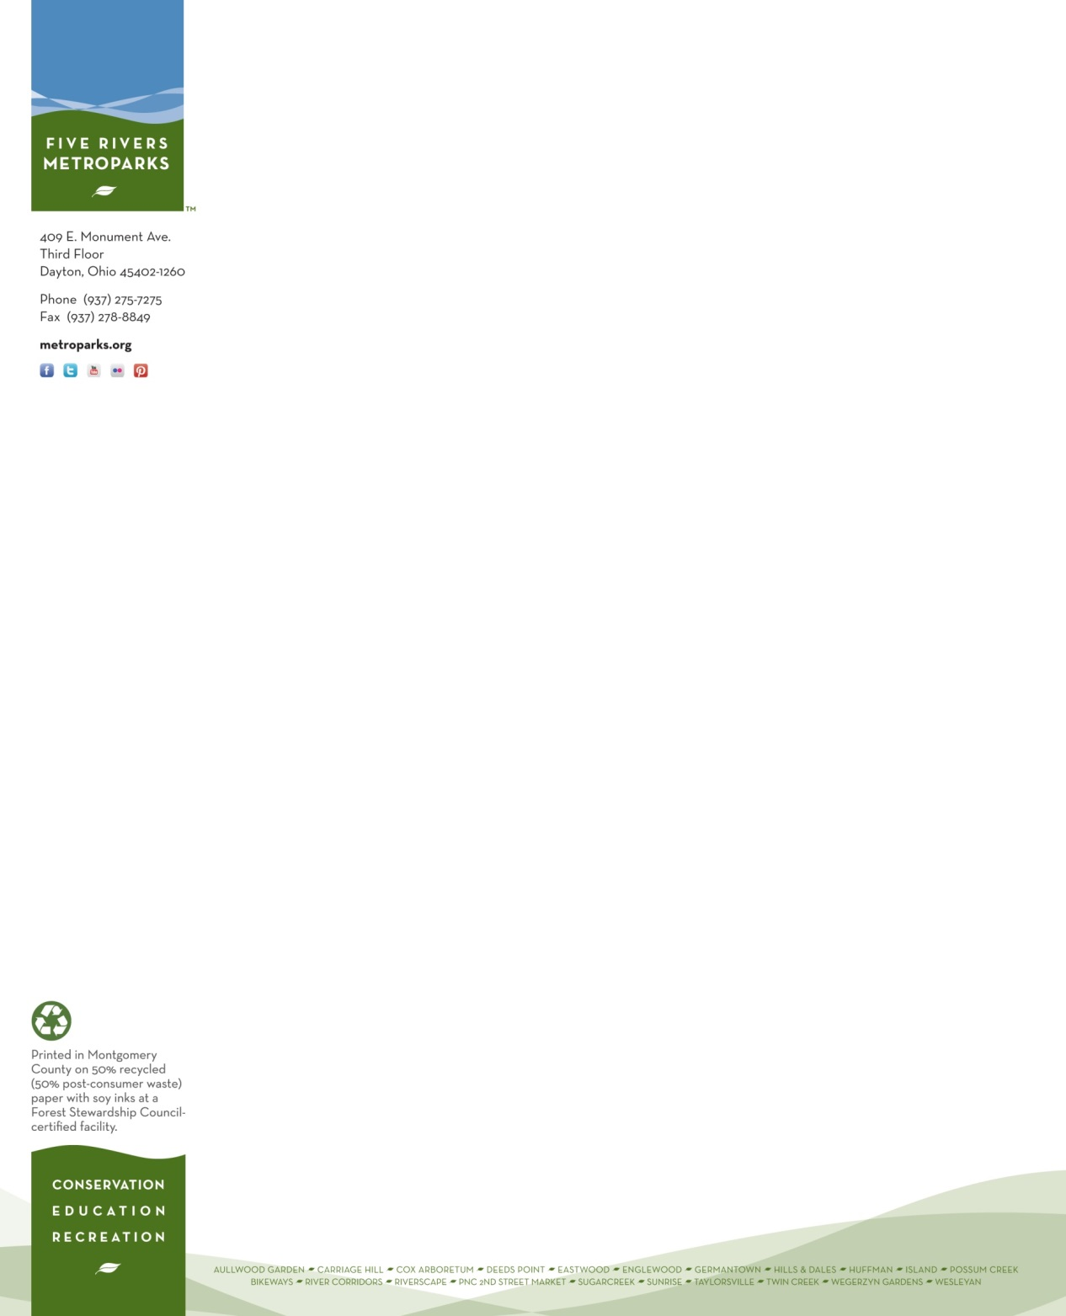
Please prominently display this pass on your vehicle dashboard during your volunteer shift while parking at:
409 E. Monument Avenue, Dayton, OH

PARKING PASS
GOOD ONLY ON THE FOLLOWING DATES:
October 24th for Make A Difference Day

Jenny J. Hymans
Volunteer Services
Five Rivers MetroPark

