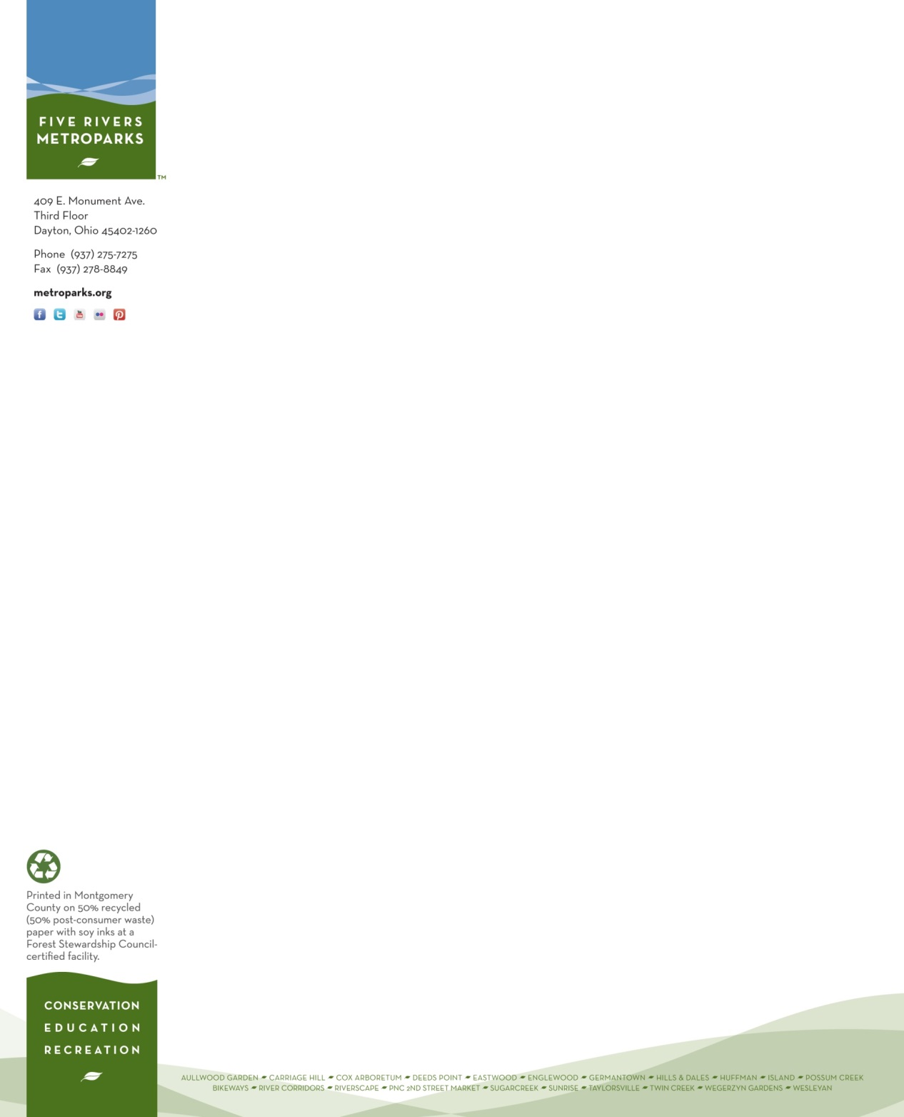
Place this parking pass on your vehicle dash when parking at our Main Office located at
409 E. Monument Avenue, for your volunteer shift on Friday, May 24th, 2024.

PARKING
PASS
(Good only on May 24th, 2024)

Amanda Wheatley

Volunteer Services
Five Rivers MetroParks

