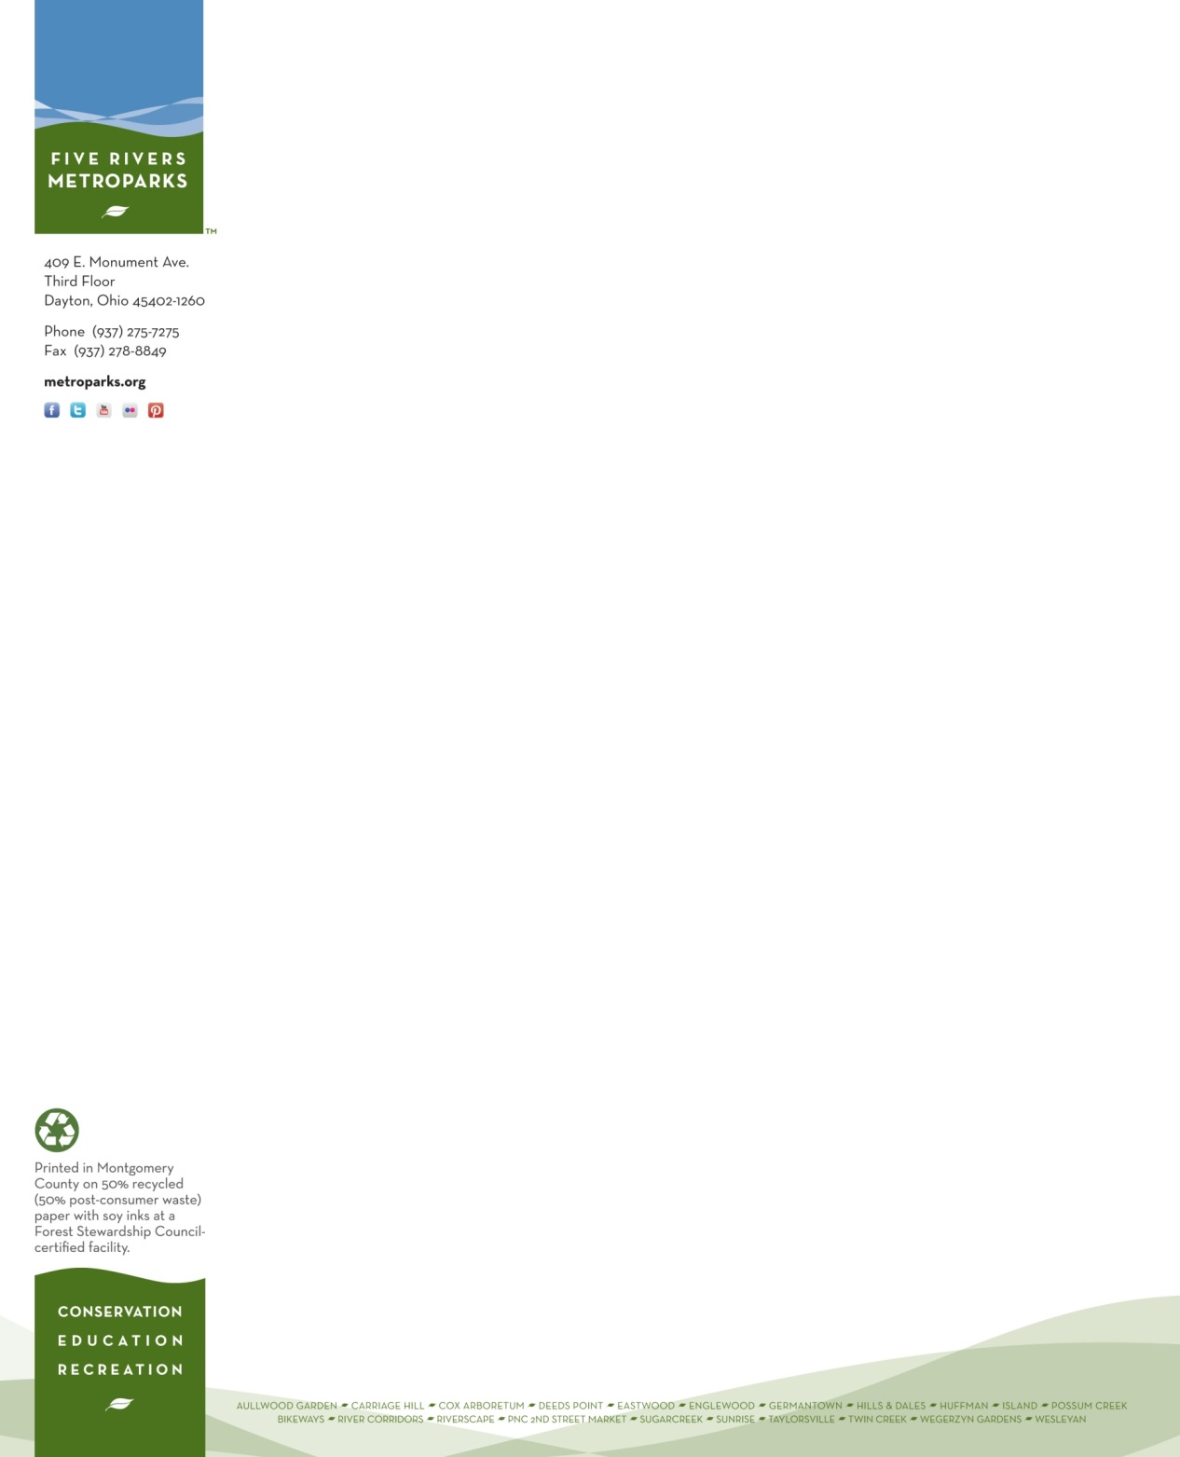**Please display on your vehicle dashboard during your volunteer shift.**

**409 E. Monument Avenue, Dayton, OH**

**PARKING PASS**

**GOOD ONLY ON THE FOLLOWING DATES:**

**5/31, 6/20, 6/27, 7/11, 8/1, 8/22, 9/29 of 2025**

**Amanda Wheatley**

**Volunteer Services Department**

**Five Rivers MetroPark**